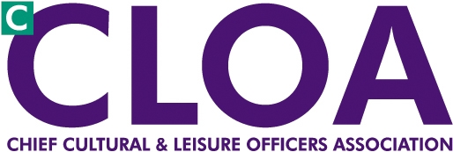

London CLOA Agenda

13 June 2012 - 14:00-16:00

Arts Council England, 14 Great Peter St, SW1P 3NQ

**14:00** Welcome and introductions Chair Toni Ainge

**14:10**  The National Archives- plans for London Malcolm Todd

and new responsibilities post MLA

**14:30** Film London - discussions with CEO’s and possible Autumn Event – Dianna Neal / Toni Ainge

**14:40**  London Councils Business Plan priorities Dianna Neal

* Libraries Project
* Philanthropic Giving

**15:00** CLOA Annual Survey**-** Questionnaire Sue Thiedeman

**15:10** Standing Items

* Borough Updates
* Notes and matters arising from 6 March 2012 meeting
* Update from NCF, National CLOA (Iain Varah)
* Cultural Agencies and London Councils written report and questions
* A.O.B.
* DONM
  + 6 November 2012 / Possible Autumn Seminar

**16:00 Close**