**London**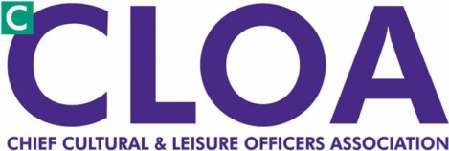

**Agenda London cCloa Afternoon Conference**

**2- 5pm, 6 November 2012**

**London Councils, 591/2 Southwark Street, SE1 0AL**

2pm Cllr Flick Rae, LGA **“Funding Outlook for Councils”**

2:30 Eric Bohl, ACTIVIST GROUP **“SOLACE Guide to commissioning and alternative funding models”**

2:50 Brian Leonard, SPORTA **“Hot Topics for the Trust Sector”**

3:10 Joel Brookfield/ Hannah Bladen, SPORT ENGLAND

3:25 Heidi Bellamy cCLOA  **“Benefits of cCLOA Membership”**

3:30 pm Q&A & Break

4:00pm Kim Wright, LB Hackney **“Opportunities for Culture to deliver on health and** **social care”**

4:30 **Facilitated sessions** (Choose one)

1. **“Engaging in Commissioning”** - this briefing aims to make you aware of the new practical resource pack jointly produced by the LGA, cCLOA, Sport England and the Arts Council’ Heidi Bellamy.
2. **“Rising to the Challenges of the Future”** – Discussion session, Howard Simmons / Laura Caton (LGA)

5:00 Close and Networking Drinks