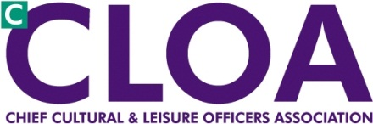 London CLOA

Agenda

5 March 2013

London Councils – 2:00 – 4:30

**2:00** Welcome and introductions Toni Ainge

**2:05** Physical activity / JSNA tool Dr Chris Payne

**2:45** Culture and Leisure Resources Database Souraya Ali

**3:05** Funding Outlook for Councils (Fair Funding) London Councils

**3:30** City Read – 2013 launch Andy Ryan

**3:55** London Cultural Peer Programme Sue Thiedeman

**4:05** Standing Items:

* Notes and matters arising from November Toni Ainge
* Update from NCF, National CLOA Iain Varah
* Cultural Agencies and London Councils written report and questions
* A.O.B.
* DONM (14:00-16:00 at London Councils)
* 2 July
* 12 November