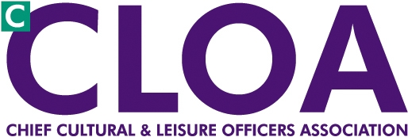

London CLOA Agenda

6 March 2012

London Councils – 14:00-16:00

**14:00** Welcome and introductions Deputy Chair Marianne Locke

**14:10**  GLA Health improvement Programme Dr Helen Walters, Director

**14:30** The role of cultural services in public health Dr David Woodhead, Hackney

**14:50**  Update on Health Integration Dr Andrew Howe, Harrow

**15:10 Questions and Discussion**

**15:40** Borough Updates, to include a special focus on the Olympics

**16:40** Standing Items

* Borough Updates
* Notes and matters arising from 20 September 2011 meeting
* Update from NCF, National CLOA Iain Varah
* Cultural Agencies and London Councils written report and questions
* A.O.B.
* DONM
  + June 2012 ACE
  + 6 November 2012

**16:00 Close**