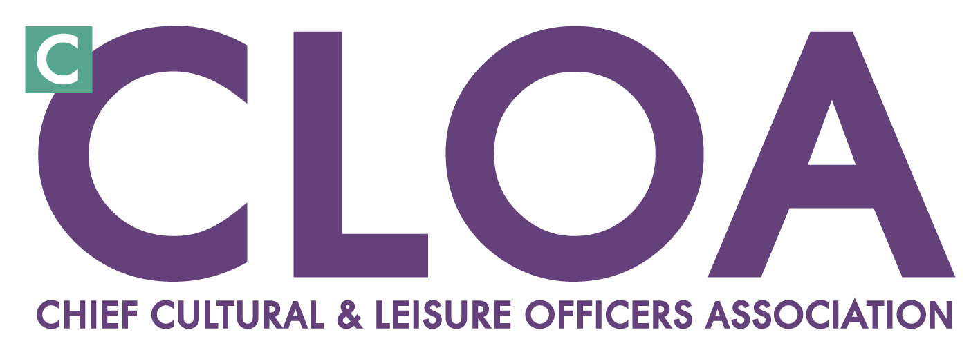CLOA AGM - 15 June 2012, Bisham Abbey
Report of John Bell, Honorary Secretary
- AGM 2011
Last year we met in the splendid surroundings of Blenheim Palace; thanks to Diana Shelton for facilitating this. Delegates were able to take advantage of a tour of Blenheim after the meeting.

- CLOA Executive
The Executive has met 4 times during the year: 21 September at the NEC (Leisure Industry Week); 27 January hosted by Sport England at their offices 7th March at the LGA/CLOA Conference in Cardiff and 4th May at the Arts Council. Members of the Executive have been active in meeting key people in the LGA, Skills Active and in arranging and hosting meetings. In October 2011 a meeting was hosted by Sharon Lea in Birmingham where CLOA members were able to hear about the groundbreaking Be Active programme which has provided valuable evidence on the cost effectiveness of physical activity to the NHS.

CLOA has been successful in creating more productive partnerships with Sport England and Arts Council and is seen as a key partner and sounding board by these agencies.

The new CLOA Chair, Richard Hunt has led these partnership meetings, aided by CLOA Vice Chairs and CLOA Executive members. Richard has instigated a full review of CLOA’s forward strategy and how CLOA conducts its business.
This has culminated in a new Communications Plan, a review of panels and working groups and a review of membership categories and benefits.

There has been a change in the administrative support for CLOA in the past year with the appointment of Heidi Bellamy as the CLOA Policy Development and Business Manager form the 1st February. CLOA is grateful to David Albutt and Sarah Gilvey for all their work for CLOA over the past 7 years.

- LGA/CLOA Conference
This year’s conference was held in Cardiff, with a strong input from CLOA. Richard Hunt took part in the opening Panel and CLOA led the Professional leadership workshops. The LGA and CLOA held a joint reception on the evening of the 7th March which created an opportunity to promote CLOA and sign up new members.

- Honorary Secretary Activity
The main activity has been to help shape the Conference agenda with the LGA’s Laura Caton. I have also contributed to Leisure Management magazine as Hon Sec of CLOA and spoken at the APSE National Conference and Hertfordshire Sports Development Conference.

