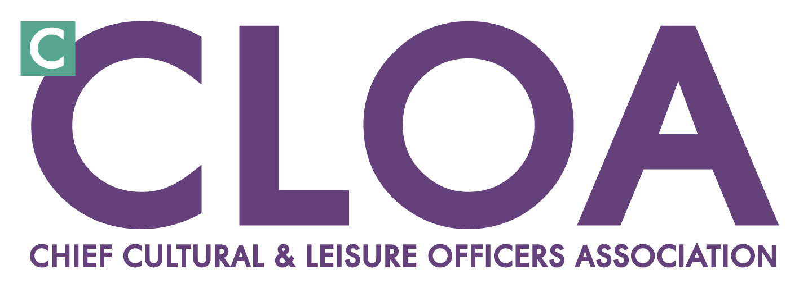Chair’s Opinion from ^{c}CLOA AGM 2012

Colleagues,

In case you hadn’t heard, we are now less than 40 days from the start of the 2012 Games. The Torch Relay is already generating fantastic scenes of enthusiasm for the Games and community spirit across the country. The negative publicity of ‘Games cost’, ticketing, torch selling and other matters for LOCOG to ponder, are gradually being put aside – and the world will fix its eyes on London and the UK for the celebrations, cultural and sporting events.

There are of course countless stories of ‘legacy’ already in place, and many of us have been on the legacy journey locally for some time re-positioning the sector. After such a powerful agenda to attach the sector for 6 years, the questions now revolve around the sector preparedness for ‘what next?’

Are we as a sector utilising every opportunity this chance presents in influencing, positioning, and improving cultural and sport sector and local outcomes that these services can contribute?

Are we ready to ‘Ride the Wave’ of the Games, and build on the euphoria of the media coverage and community engagement that will follow in the next few weeks?

And are we ready to step up our efforts post Games when it gets harder for the sector in the post Games calm or anti-climax, as the 2012 wave retreats in early September?

I believe there are the three core areas of focus for the sector as we move into ‘legacy mode’ that we can find both space to develop, and find the ears of local leaders. The three areas are
- Economic growth, skills and jobs
- Health and wellbeing
- Innovation, transformation and efficiency

The public sector financial realities will drive more change for our sector, as it will across all public services. With years of low growth projected and public expenditure cuts till at least 2017/18 the forecast message is of a decade of austerity. The scale of change makes it difficult to imagine what local government will look like in a decade. So for the culture and sport sector leaders we need to proactively shape change in partnerships, maintain profile and be an integral part of the solution in the 3 key agendas.

This has been certainly one of the most challenging and fast moving years that I can remember for the sector. When I accepted the nomination of Chair of ^{c}CLOA last June, I recognised that for many ^{c}CLOA members this year we would be working differently, changing roles, be rationalising services and making massive savings across services. This would be the key challenge for ^{c}CLOA, understanding these changes, leading the debate and direction in this new environment, and supporting and engaging members in this process.

To support us in this challenge we are actively monitoring the impact of a reducing settlement for local government. I wanted to share with you some headlines from ^{c}CLOA’s latest financial survey.

- This year no specific service area has been immune to budget reduction. The services hit hardest, with cuts exceeding 15%, once again include arts, sports development, sport and leisure facilities, with museums joining the ranks of services under the squeeze.

- Based on returns, we estimate cautiously that there has been a loss of over 2800 jobs nationally from the sector, with cuts notably affecting front line services such as libraries, leisure centres and development posts in arts, museums and sports.

- Community grants are still taking a share of the pain with 55% of local authorities implementing a reduction in at least one service area compared with just 30% last year.

- Driving up income - 27% of respondents had introduced a charge significantly higher than the current RPI in one or more area; with a number of authorities opting to introduce charges for services and activities that were previously free.

- Additional income has been secured through strategic commissioning and 70% of the authorities responding to this question cited that they had been successful. Working to deliver outcomes for PCT’s/Public Health/Health & Well-being Boards has generated the most opportunities.

- And in terms of capital development, all of the authorities responding confirmed they would be making some investment (above £500k) over the next 3 years.

Our purpose in producing this analysis is not about painting a picture of cuts (we are all living them daily) but about learning how as a sector we are bucking trends, gaining opportunity, innovating or taking radical directions for future sustainability. We will build on this with members this year and share the learning.

As I enter my second year as ^{c}CLOA Chair my continued emphasis will be to engage more member activity and input into our work, and from a wider sector base. As ever our success relies heavily on ^{c}CLOA members playing their part, engaging in debate, sharing and supporting fellow colleagues through peer support and networking, giving just a bit back to the sector. Together our expertise adds up to the most valued opinion in the sector. Make sure you play your part with ^{c}CLOA.

