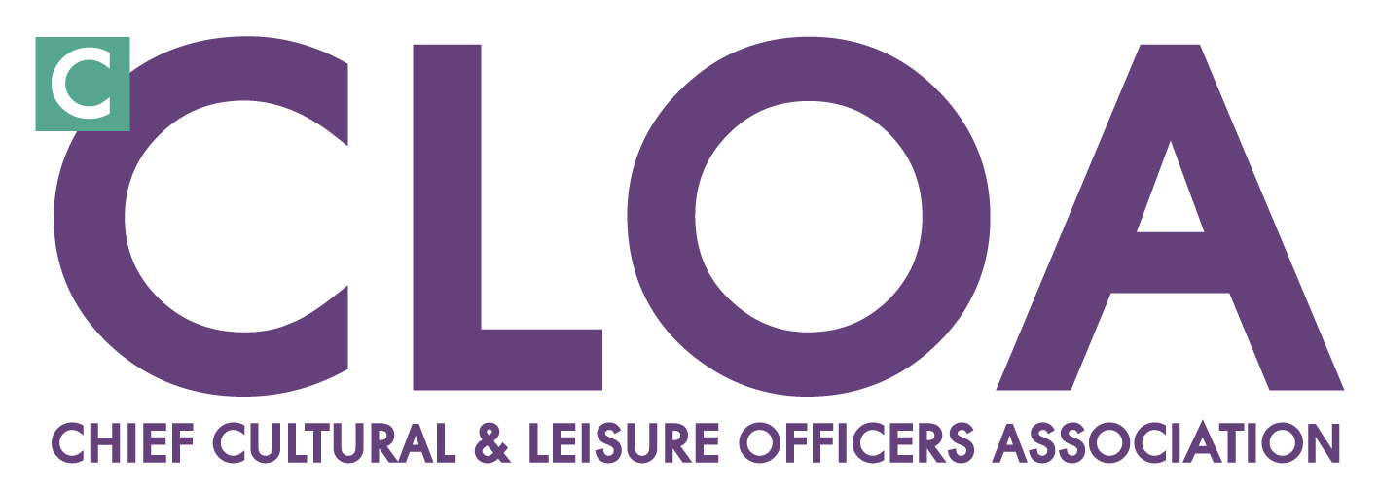

Financial Settlements for Culture & Sport
Survey Summary – June 12

To assist ^{c}CLOA with its advocacy for the sector in March 2011 we compiled a short survey to gain an insight into the savings made across culture and leisure services following the Comprehensive Spending Review.

The aim was to establish the impact on budgets and initial response to the challenges faced by the culture and sport sector. This survey enabled us to provide a high level snapshot of the financial environment for culture and leisure services.

To help us update this picture, we carried out a similar survey in May 2012 to establish the level of savings local authorities have needed to make in the current financial year and are planning to make over the next twelve months.

62 local authorities responded to the request for information, representing 17.5% of the 353 local authorities in England. Geographically more responses were received from the South East, East, East Midlands, South West and London. Returns from the West Midlands, North East, North West, South West and Yorkshire and Humber were lower.

It is notable that the highest response rates to the survey correlate with where ^{c}CLOA Regional groups or Cultural Improvement Networks are active.

Key findings:

The overall picture of savings already implemented across culture and leisure services is as follows:

38% of responding authorities were implementing savings of up to 5%
17% of responding authorities were implementing savings of between 5% and 10%
24% of responding authorities were implementing savings of over 10%
21% of responding local authorities were implementing savings of over 15%
20 authorities did not provide a response.
Furthermore, projected savings for culture, sport and leisure budgets for 2013/14 are as follows:

31% of authorities are projecting up to 5% further savings from budgets
19% of authorities are projecting between 5% and 10% of further savings
14% of authorities are projecting over 10% further savings from budgets
17% of authorities are projecting over 15% further savings from budgets
19% of authorities have not yet firmly established future levels of savings
20 authorities did not provide a response.
Whilst only 5 authorities are making savings of 10-15% + across consecutive financial year's, our previous survey suggested that around 40% of authorities will yield culture, sport and leisure savings in line with required overall 21% local government CSR reduction.

Making the savings

Conscious that savings of this level are rarely achieved wholly through back office or support functions, we asked a range of additional questions in order to ascertain where the savings are falling. The chart below indicates that Libraries and Sports & Leisure Facilities along with Arts venues and Tourist information Centres are susceptible to closure as part of the move to reduce on-going revenue associated with maintaining assets.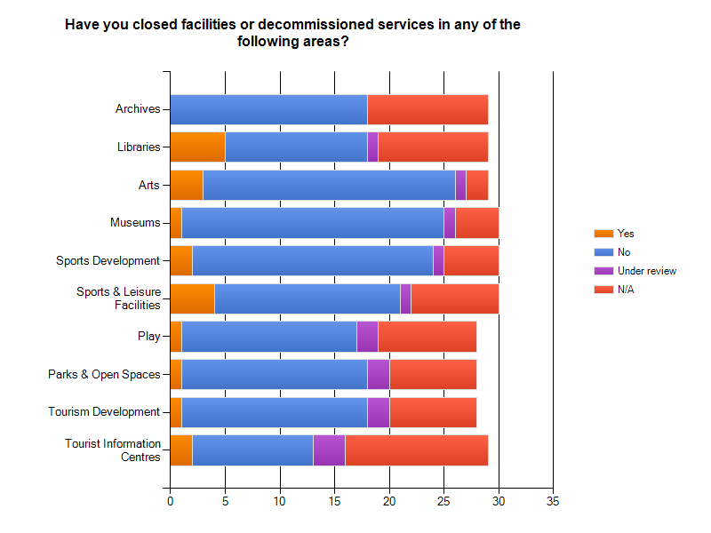
Additionally, responding authorities stated that circa 500 full time equivalent jobs have been lost over the past year. Potentially, this represents a loss of over 2800 jobs nationally, with cuts notably affecting front line services such as libraries and leisure centres and also development posts in arts/museums/sports.

Winners and losers across culture, sport and leisure budgets

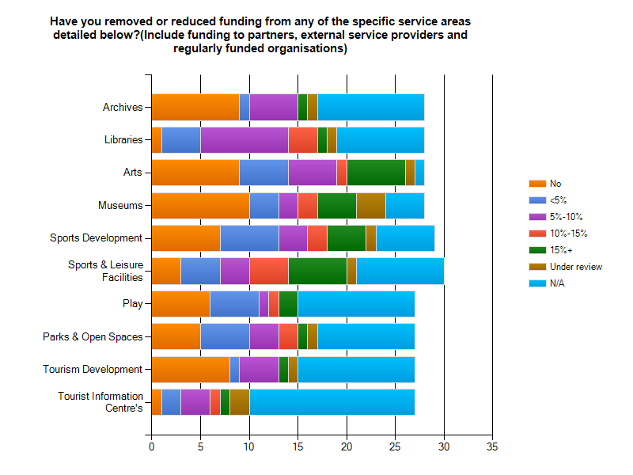

The chart above illustrates the extent to which funding has been reduced or removed from specific service areas.

Last year the service areas that avoided heavier cuts (under 5% savings) were archives and play. However, this year no specific service area has been immune to budget reduction.

The services hit hardest, with cuts exceeding 15%, cited by the highest number of local authorities are once again arts, sports development, sport and leisure facilities, with museums joining the ranks of services under the squeeze.

The survey also asked respondents to indicate whether they had removed or reduced community grants to the cultural and sports sector. The findings suggest that 55% of local authorities have needed to implement a reduction in at least one service area; this is an increase on earlier data that suggested 30% of authorities had made cuts to community grants. In terms of an emerging trend, the area’s most commonly targeted for grant cuts were again arts and sports, with 45% of responding authorities making savings.

Driving up income

An additional line of enquiry in the survey this year aimed to identify the extent to which local authorities were seeking to increase revenue income from charges as the preferred mechanism for balancing budgets.

The response indicated that 27% of local authorities had introduced a charge significantly higher than the current RPI in one or more area; with a number of authorities opting to introduce charges for services and activities that were previously free. This increase in the cost of taking part, alongside falls in disposable incomes, may have negative repercussions for the aim to broaden participation in culture and sport.

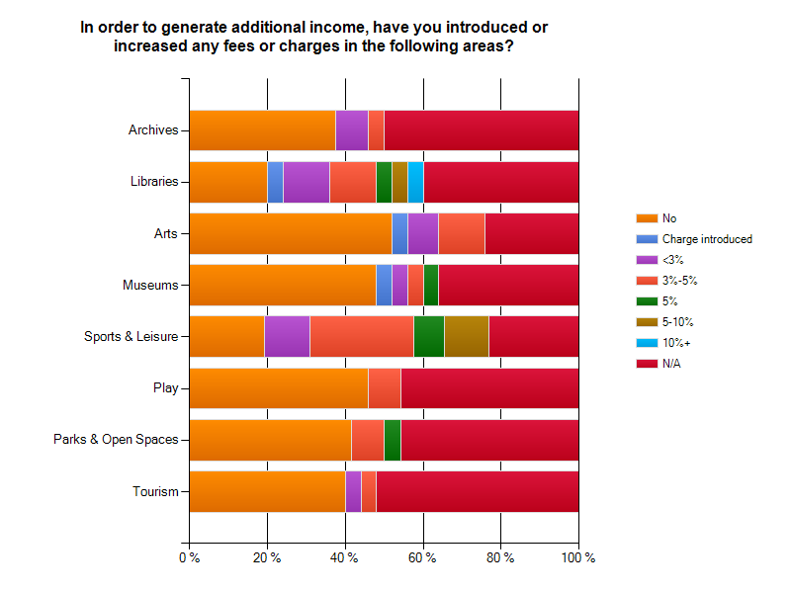

On a positive note, we also asked whether additional income had been secured through strategic commissioning and 70% of the authorities responding to this question cited that they had been successful.

Working to deliver outcomes for PCT’s/Public Health/Health & Well-being Boards has generated the most opportunities, but Community Safety Partnerships, Children & Young Peoples Services, Adult Social Care provision and Local Enterprise Partnerships have all commissioned outcomes based provision from our sector as the graph below illustrates.

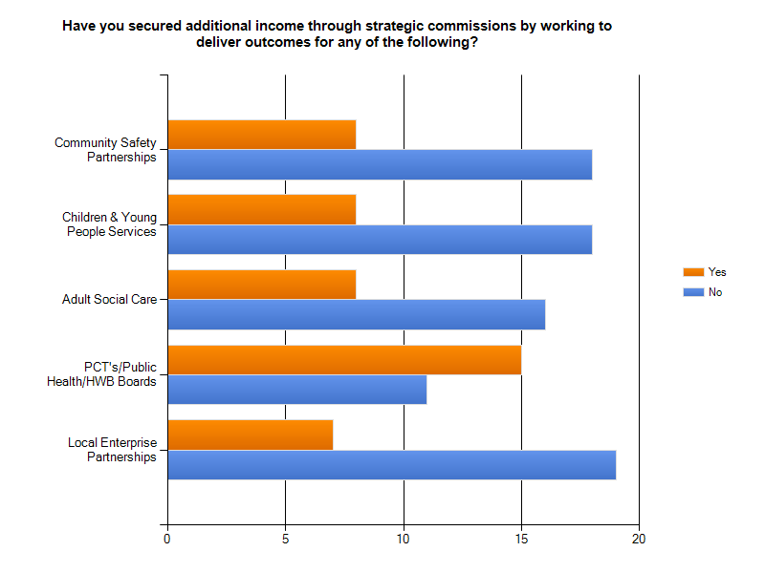New ways of working

Last year over 50% of respondents stated that they were currently undertaking or considering alternative delivery models and in 27 authority’s transformation of the delivery of culture or sport services was already underway.

This year 96% answered positively to this question, illustrating the speed with which a move to new ways of working has been embraced by:
- Sharing assets or co-location with another service provider (46% respondents)
- Transferring assets to a community group (44% respondents)
- Sharing services with another local authority (41% respondents)
- Externalising service delivery through a Trust (39% respondents)
- Externalising service delivery through a private contractor (16% respondents)

We also asked respondents to estimate the value of savings made through adopting new ways of service delivery. For many organisations it is too early to confirm, however those who were prepared to give figures cited between £100K-500K p.a over periods of up to 14 years. It is worth noting however that whilst this route may provide a solution for many local authorities, a number advised that, after due consideration, they had declined alternative delivery vehicles as a viable option.

Future investment

In terms of capital development we asked whether plans were in place to invest in any of the associated service areas over the next 3 years.

All of the authorities responding confirmed they would be making some investment, with Sports & Leisure Facilities likely to achieve the most significant sums (1 million +) in 50% of local areas, which may well be linked to initiatives arising through public/private partnerships. Libraries are due to receive similar injections of investment in 31% of responding local authorities and Play Areas are well placed to scoop up smaller sums (under £500K 39%).

Arts venues, tourism attractions and archives, with the exception of some isolated large-scale capital investment, currently seem less of a priority for those responding authorities. It will be interesting to monitor the impact the inclusion of ‘cultural well-being’ in the National Planning Policy Framework has on future decision-making, with a directive to deliver sufficient cultural facilities to meet local needs as a core planning principle.

Summary

This year no specific service area has been immune to budget reduction. The services hit hardest, with cuts exceeding 15%, once again include arts, sports development, sport and leisure facilities, with museums joining the ranks of services under the squeeze.

Based on survey returns, we estimate cautiously that there has been a loss of over 2800 jobs nationally from the sector, with cuts notably affecting front line services such as libraries, leisure centres and development posts in arts, museums and sports. This raises issues for sector leadership and will, in some localities, seriously impact on the ability of culture and sport to contribute to broader outcomes.

Furthermore, the survey suggests that this picture of diminishing provision is compounded by the fact that 55% of local authorities are also implementing a reduction to community grants in at least one service area compared with just 30% last year.

However, our purpose in producing this analysis is not about painting a picture of cuts, but about learning how as a sector we are bucking trends, gaining opportunity, innovating or taking radical directions for future sustainability. And the survey illustrates how leaders are mitigating damage by driving up revenue through service charges, making the case for capital investment and responding positively to the opportunities to secure additional income through strategic commissioning.

This is an area that ^{c}CLOA are keen to support and, in partnership with LGA, Sport England and Arts Council England, will shortly publish new resources to help culture and sport providers better engage with the strategic and other commissioning processes now taking place across councils and communities.

Monitoring the impact of financial austerity on both political decision-making and policy implementation, seeking to understand these changes, leading the debate and direction in this new environment and supporting our members in this process will remain a key focus for ^{c}CLOA over the coming months.

21 county, 16 unitary, 13 district, 11 borough and 1 city council
For the purpose of this survey culture and leisure services includes libraries and archives, arts, museums, sports development and leisure facilities, play, parks and open spaces, tourism development and TIC’s, partnership and community grants.
RPI inflation was 3.5% in April 2012, Office for National Statistics
46 local authorities answered this question
27 local authorities answered this question

